2024 Mobile Screening Imaging Distribution

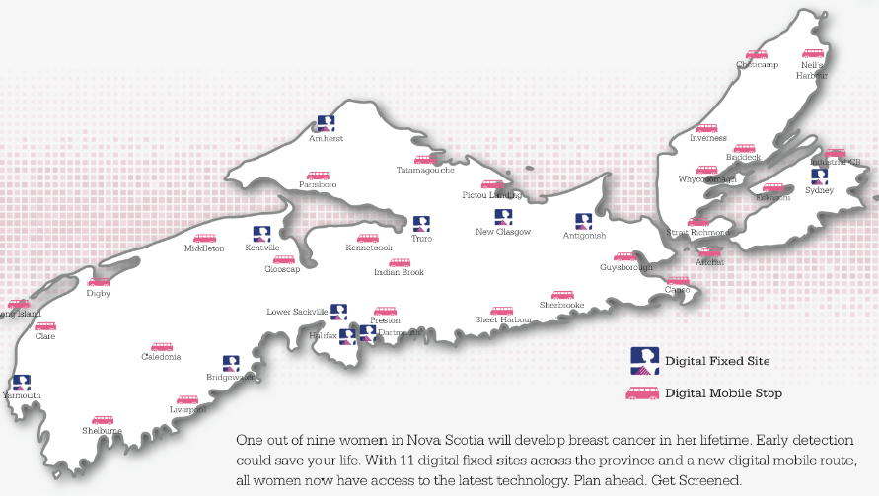

|  |  |  |  |  |  |  |  |
| --- | --- | --- | --- | --- | --- | --- | --- |
| Mobile Stop | Date(s) of Visit | Reported | Registered | Hospital  Network | PACS  Admin | #  DAYS | MAX# of  Screens |
| Industrial CB (CB, GB, NW, NS) | Jan 1 – June 1 | SYD | SYD | YES | CBR | 145 | 7305 |
| Neil’s Harbour | June 3 - 8 | SYD | SYD | YES | CBR | 6 | 307 |
| Cheticamp | June 10 - 19 | SYD | SYD | YES | CBR | 9 | 465 |
| Inverness | June 20 - 29 | SYD | SYD | YES | CBR | 9 | 476 |
| Pictou Landing | July 2 | NG | NG | NO | ARH | 1 | 25 |
| Tatamagouche | July 3 - 6 | TR | TR | Wireless | CRH | 4 | 197 |
| Parrsboro | July 8 - 9 | AM | AM | Wireless | CCR | 2 | 79 |
| Indian Brook | July 10 - 11 | TR | TR | NO | CRH | 2 | 68 |
| Kennetcook | July 12 - 13 | TR | TR | NO | CRH | 2 | 102 |
| Hantsport | July 15 | KE | KE | NO | VRH | 1 | 24 |
| Middleton | July 16 – Aug 3 | KE | KE | Wireless | VRH | 17 | 755 |
| Digby | Aug 6 - 21 | BR | YA | Wireless | SSRH | 14 | 624 |
| Long Island | Aug 22 - 23 | BR | YA | NO | SSRH | 2 | 56 |
| Clare | Aug 24 - 31 | BR | YA | NO | SSRH | 7 | 292 |
| Shelburne | Sep 3 - 11 | BR | YA | Wireless | SSRH | 8 | 347 |
| Liverpool | Sept 12 - 25 | BR | BR | NO | SSRH | 12 | 550 |
| Caledonia | Sept 26 - 28 | BR | BR | NO | SSRH | 3 | 128 |
| North Preston | Oct 1 - 2 | NG | HC | NO | ARH | 2 | 76 |
| Sheet Harbour | Oct 3 - 9 | NG | HC | YES | ARH | 6 | 280 |
| Sherbrooke | Oct 10 - 12 | AN | AN | NO | SMH | 3 | 143 |
| Guysborough | Oct 15 - 17 | AN | AN | NO | SMH | 3 | 148 |
| Canso | Oct 18 - 21 | AN | AN | NO | SMH | 3 | 112 |
| Arichat | Oct 22 - 29 | AN | AN | YES | SMH | 7 | 368 |
| Cleveland | Oct 30 – Nov 9 | AN | AN | YES | SMH | 10 | 546 |
| Whycocomagh | Nov 12 - 13 | SYD | SYD | NO | CBR | 2 | 93 |
| Baddeck | Nov 14 - 23 | SYD | SYD | YES | CBR | 9 | 492 |
| Eskasoni | Nov 25 – 28 | SYD | SYD | NO | CBR | 4 | 201 |
| Sydney | Nov 29 – Dec 31 | SYD | SYD | YES | CBR | 20 | 1084 |